

A MINI PROJECT REPORT
on
Student Grade Calculator
Submitted by

VANISHREE MODI

NH25CSD804-T

Under the guidance of

Ms. M.THANGA SUBHA DEVI
Sr.Assitant Professor
In partial fulfillment for the award of the degree of

BACHELOR OF ENGINEERING
in
COMPUTER SCIENCE AND ENGINEERING
Academic Year: 2025-26 (ODD SEM)

CERTIFICATE
This is to certify that the mini project work titled “Student Grade Calculator” is a bonafide work carried out by VANISHREE MODI (NH25CSD804-T) in partial fulfillment of the degree of Bachelor of Engineering in Computer Science and Engineering of the New Horizon College of Engineering during the year 2025-2026.

Signature of Guide Signature of HOD

SEMESTER END EXAMINATION

Name of the Examiner Signature with date
1.
2.

ABSTRACT

The Student Grade Calculator is a web-based application developed using HTML, CSS, and JavaScript with the objective of simplifying and automating the evaluation of student performance. Traditionally, the process of calculating grades involves repetitive manual calculations, which are prone to human error and can become highly inefficient when dealing with multiple students. This project overcomes these limitations by providing a fast, accurate, and user-friendly system that computes total marks, percentage, individual subject pass/fail results, and overall grade in real time.

The system accepts student details along with marks for six subjects and validates the input to ensure that all entries fall within the acceptable academic range. JavaScript serves as the core computational engine, performing tasks such as calculating totals, averages, percentages, and applying institutional pass/fail criteria. CSS enhances user experience by offering a visually structured and responsive layout, while HTML ensures the semantic organization of input fields, sections, and result components.

The Grade Calculator is fully client-side, which allows the application to run on any modern browser without requiring backend servers or databases. The system also highlights subject-wise performance, enabling students to identify their strengths and areas requiring improvement. Furthermore, the application is designed to be easily extendable, allowing future integration of additional subjects, downloadable report cards, data storage, and enhanced analytics.
This project demonstrates the effective application of web technologies to solve academic problems with accuracy and efficiency. By automating the grading process, the Student Grade Calculator not only reduces human effort but also ensures transparency and reliability in academic assessments..

ACKNOWLEDGEMENT
The satisfaction and euphoria that accompany the successful completion of any task would be impossible without the mention of the people who made it possible, who’s constant guidance and encouragement crowned our efforts with success.
I have great pleasure in expressing gratitude to Dr. Mohan Manghnani, Chairman, New Horizon Educational Institutions, for providing necessary infrastructure and creating good environment.
I take this opportunity to express my profound gratitude to Dr. Manjunatha, Principal, New Horizon College of Engineering, for the constant support and encouragement.
I would like to thank Dr. Anandhi R J, Professor and Dean-Academics, NHCE, for her valuable guidance.
I would also like to thank Dr. B. Rajalakshmi, Professor and HOD, Department of Computer Science and Engineering, for the constant support.

I also express my gratitude to Ms.M.THANGA SUBHA DEVI,SR.ASSITANT PROFESSOR Department of Computer Science and Engineering, my mini project reviewer, for constantly monitoring the development of the project and setting up precise deadlines. Her valuable suggestions were the motivating factors in completing the work.

VANISHREE MODI
NH25CSD804-T

CONTENTS
ABSTRACT | I
ACKNOWLEDGEMENT | II
CONTENTS | III
LIST OF FIGURES | V
INTRODUCTION | 1
1.1 PROBLEM DEFINITION | 1
OBJECTIVES | 2
1.3 METHODOLOGIES TO BE FOLLOWED | 3
FUNDAMENTALS OF THE LANGUAGES USED | 4
2.1 HTML | 4
2.2 HTML TAGS | 6
2.3 CSS | 6
2.4 JAVASCRIPTS | 7
2.5 XHTML | 8
2.6 XML | 9
REQUIREMENT SPECIFICATION | 11
3.1 HARDWARE REQUIREMENTS | 11
3.2 SOFTWARE REQUIREMENTS | 11
DESIGN | 12
4.1 DESIGN GOALS | 12
IMPLEMENTATION | 13
5.1 HOME PAGE | 13
5.2 PROFILE PAGE | 15

5.3 | SIGNUP AND LOGIN PAGE | 16
RESULTS |  | 17
6.1 | MAIN PAGE | 17
6.2 | PROFILE PAGE | 19
6.3 | SIGNUP AND LOGIN PAGE | 20
CONCLUSION |  | 20
REFERENCES 21

LIST OF FIGURES

Figure No. | Description | Page No.
1.1 | Student Grade Calculator – Home Interface | 5
1.2 | Student Details Input Section | 6
2.1 | Subject Marks Entry Section | 7
2.2 | Result Display Box (Pass/Fail Output) | 8
2.3 | Calculation Workflow of the Grade System | 9
4.1 | CSS Styling Structure Diagram | 12
4.2 | CSS Box Model Representation | 13
4.3 | HTML Tags Classification Diagram | 14
4.4 | HTML Tag Nesting Representation | 15

LIST OF TABLES

Table No. | Description | Page No.
1.1 | Student Information Input Fields | 6
1.2 | Subject Marks Entry Format | 7
2.1 | Grade Classification Criteria | 9
2.2 | Final Result Output Structure | 10
3.1 | Hardware Requirements | 12
3.2 | Software Requirements | 13

CHAPTER 1

INTRODUCTION

PROBLEM DEFINITION

In academic institutions, evaluating student performance accurately and efficiently is essential for monitoring progress and providing timely feedback. Traditionally, calculating grades involves manually entering marks, checking individual subject pass/fail status, calculating totals, averages, percentages, and assigning grades based on predefined criteria. This manual procedure is prone to human errors, time-consuming, and inconsistent when done repeatedly for multiple students. Hence, there is a need for an automated, user-friendly system that simplifies the entire grade evaluation process.

The Student Grade Calculator aims to solve this problem by providing a web-based platform where a user (teacher or student) can input marks for six different subjects: Software Engineering & Project Management, Mathematics, Digital Logic Design, Optimization Technique, Web Design Technology, and Advanced Data Structure. The system automatically validates the input values, ensuring that marks lie within the permissible range (0–100). It also ensures that the grade is calculated only after all fields are filled, thereby preventing incomplete or inaccurate results.

Once valid data is entered, the system determines whether the student has passed or failed by checking the minimum passing requirement of 35 marks per subject. If any subject is below the threshold, the system instantly declares the student as FAIL and displays the subject-wise pass/fail breakdown. If the student passes all subjects, the calculator proceeds to compute the total marks (out of 600), average marks, percentage score, and finally assigns a grade according to the defined grading scale (A+, A, B, C, D, or Fail).

The project also addresses usability issues by offering a clean, structured, and visually appealing interface. Features such as input restrictions, automatic uppercase conversion for USN, reset functionality, and organized result display make the tool efficient and effortless to use. The consistent layout and intuitive design help minimize confusion and improve user experience.

OBJECTIVES
The main objective of this project is to design and develop a Student Grade Calculator that simplifies the process of evaluating student performance in a fast, accurate, and user-friendly manner. In academic environments, teachers and students often spend considerable time manually calculating totals, averages, percentages, and grades. This manual process is prone to human errors, inconsistency, and delays. To overcome these issues, this project aims to create an automated system that performs all calculations accurately while offering an intuitive interface for entering and reviewing student details.
The system aims to ensure that every user can easily input marks for all subjects and instantly generate a clear and comprehensive grade report. A key objective is to validate all entered marks to ensure correctness and prevent errors such as missing data or invalid values outside the range of 0–100. The calculator is also designed to determine the pass or fail status of the student by checking each subject individually. If the student has failed in any subject, the system immediately displays subject-wise performance to provide clarity and transparency.
Another important objective of this project is to present the final results in a structured and visually appealing manner. The output includes the student’s total marks, average score, percentage, overall grade, and detailed pass/fail status for each subject. This organized presentation helps users quickly interpret the results without confusion. Additionally, the interface is built to be clean, modern, and responsive, ensuring ease of use and smooth interaction for all types of users.
The system aims to minimize the workload of faculty members by automating repetitive calculations while reducing the risk of calculation mistakes. It also enhances accessibility for students by allowing them to instantly evaluate their performance. By integrating validation, automation, and well-designed output formatting, the Student Grade Calculator serves as a reliable and efficient solution for academic assessment. Overall, the objective is to create a tool that is accurate, user-friendly, visually clear, and capable of improving the overall efficiency of grade computation.

METHODOLOGIES TO BE FOLLOWED

The development of the Student Grade Calculator follows a systematic and structured methodology to ensure accuracy, efficiency, and user satisfaction. The process involves a series of well-defined stages, each contributing to the successful design and implementation of the system. The methodology is centered around understanding user needs, planning the system structure, designing an intuitive interface, writing efficient code, and thoroughly testing the final product to guarantee reliability.

The first step in the methodology is the requirement analysis. During this stage, the functional and non-functional requirements of the project are clearly identified. This includes determining the input fields such as student name, USN, and marks for six subjects, along with output results including total marks, average, percentage, grade, and subject-wise pass/fail status. Understanding user expectations ensures that the system is aligned with academic needs and provides the intended functionality.

The second stage involves system design, where the complete structure and flow of the application are planned. This includes designing the user interface layout, deciding input validation rules, and structuring the output display. Attention is given to readability, ease of use, and arranging the form elements in a logical manner. The visual design aims to be clean, organized, and user-friendly to provide smooth interaction.

The next phase is implementation, where the actual development is carried out using HTML, CSS, and JavaScript. HTML is used to structure the form and input fields, CSS is employed to style the interface and enhance visual appearance, and JavaScript handles the core logic of the calculator. This includes validating inputs, calculating totals and averages, determining pass/fail status, and generating the final report. The implementation follows coding standards to ensure clarity, maintainability, and efficiency.
After implementation, the system undergoes testing and verification.

Each part of the calculator is tested individually and together to ensure correct functioning. Input validation, calculation accuracy, border conditions, and display formatting are thoroughly tested. Special tests are performed to check whether the system correctly handles failing subjects and prevents calculation when fields are incomplete. This ensures that the system is robust, error-free, and ready for real use
.
The final stage is evaluation and refinement, where the system is reviewed for usability and performance. Based on feedback from test users or instructors, improvements are made to enhance functionality or visual presentation. This iterative refinement ensures the final product meets high standards of accuracy, efficiency, and user satisfaction.

CHAPTER 2

FUNDAMENTALS OF THE LANGUAGES USED

HTML
HyperText Markup Language (HTML) is the foundational language used to create and structure content on the web. It is a markup language, not a programming language, meaning it describes the structure and layout of a webpage using predefined tags. HTML acts as the backbone of any website or web application, including the Student Grade Calculator developed in this project. By providing a standardized way to define text, forms, inputs, headings, tables, and layout elements, HTML plays a crucial role in designing user interfaces that are accessible and well-organized.
HTML operates based on the use of tags, which are enclosed within angle brackets, such as <html>, <body>, <h1>, <p>, and <input>. These tags define the functionality and purpose of each element on the page. Most HTML elements come in pairs: an opening tag and a closing tag, which together wrap around content to give it structure. For example, <h1>Title</h1> defines a top-level heading. Some tags, like <img> and <input>, are self-closing and do not require an ending tag. HTML documents follow a hierarchical structure, beginning with the <!DOCTYPE html> declaration, followed by the <html> root, then <head> for metadata, and <body> for visible content.
One of the fundamental strengths of HTML is its ability to integrate easily with other technologies such as CSS and JavaScript. HTML handles the structural layer, CSS manages the presentation layer, and JavaScript controls interactivity and logic. In the Student Grade Calculator, HTML is used to create form fields for entering student details and subject marks, labels for identifying those inputs, headings for section titles, and containers for displaying results. The HTML layout ensures that the user interface is intuitive and clearly aligned, allowing users to easily enter data and interpret output.
Forms are an essential part of HTML when developing interactive systems. The <form> element, combined with input tags like <input type="text">, <input type="number">, and <button>, allows users to enter and submit data. HTML validation properties and attributes help ensure that only correct and meaningful data is submitted. In this project, HTML forms provide the primary interface for collecting student information, while JavaScript processes the data behind the scenes.
HTML is also designed with accessibility in mind. Proper use of labels, headings, and structure ensures that web applications are easier to navigate and understand, even for users relying on screen readers. Its compatibility across all browsers and devices makes HTML the most reliable choice for building the core structure of any web-based tool.
Overall, HTML serves as the foundational building block of the Student Grade Calculator, enabling the creation of a structured, readable, and user-friendly interface. Its simplicity, universality, and flexibility make it an essential technology for modern web development.

HTML TAGS

HTML (HyperText Markup Language) uses tags to structure and display content on a webpage. Tags are enclosed within angle brackets < > and usually come in pairs: an opening tag <tag> and a closing tag </tag>. Some tags are self-closing, meaning they do not require an end tag.

Below are the commonly used HTML tags grouped by purpose:

1. Basic Structure Tags
Tag | Purpose
<!DOCTYPE html> | Declares the document type as HTML5
<html> | Root element of an HTML document
<head> | Contains metadata, title, links, scripts
<title> | Sets the browser tab title
<body> | Contains visible webpage content

2. Text Formatting Tags
Tag | Purpose
<h1> to <h6> | Headings (H1 is largest)
<p> | Paragraph
<b> / <strong> | Bold text
<i> / <em> | Italic text
<u> | Underline
<br> | Line break (self-closing)
<hr> | Horizontal line (self-closing)

3. List Tags
Tag | Purpose
<ul> | Unordered list (bullets)
<ol> | Ordered list (numbers)
<li> | List item

4. Image & Media Tags
Tag | Purpose
<img> | Displays an image (self-closing)
<audio> | Plays audio
<video> | Plays video

5. Link & Navigation Tags
Tag | Purpose
<a> | Hyperlink
<nav> | Navigation block

6. Table Tags
Tag | Purpose
<table> | Table
<tr> | Table row
<td> | Table data/cell
<th> | Table header cell
<caption> | Table title

7. Form Tags (Very Important for Your Project)

Used for inputs in your Student Grade Calculator.
Tag | Purpose
<form> | Creates a form
<input> | User input (text, number, checkbox, etc.)
<label> | Label for input
<button> | Clickable button
<select> | Dropdown menu
<option> | Dropdown option
<textarea> | Multi-line text box

8. Layout & Container Tags
Tag | Purpose
<div> | Block container (used for layout)
<span> | Inline container
<header>, <footer> | Page header/footer
<section>, <article> | Page sections
<main> | Main content area

⭐ 9. Self-Closing Tags
Tag | Purpose
<br> | Line break
<hr> | Horizontal rule
<img> | Image
<input> | Form input

CSS
Cascading Style Sheets (CSS) is the presentation language used to control the visual appearance of HTML content. While HTML provides the structure and semantics of a webpage, CSS defines layout, typography, colors, spacing, and responsive behavior. In the Student Grade Calculator project, CSS is responsible for producing a clean, readable, and professional interface that improves usability and comprehension.

How CSS is applied
CSS can be included in three ways: (1) inline with an element using the style attribute, (2) embedded inside a <style> block in the HTML <head>, and (3) in an external .css file linked with <link rel="stylesheet" href="styles.css">. Using an external stylesheet is recommended for separation of concerns and reusability across pages.

Selectors and specificity
Selectors target the HTML elements to style: element selectors (p), class selectors (.card), id selectors (#header), descendant selectors (.card p), and attribute selectors (input[type="number"]). CSS follows a specificity hierarchy (id > class > element) and the cascade principle: later rules override earlier ones when specificity ties.

Box model & spacing
Every HTML element is a box composed of content, padding, border, and margin. Controlling these four properties allows precise spacing and visual grouping. box-sizing: border-box; is often used so padding and borders are included in the element’s declared width.

Layout techniques
CSS provides layout tools: traditional flow, floats (legacy), and modern methods like Flexbox and CSS Grid. Flexbox (display: flex) is ideal for one-dimensional layouts (horizontal rows or vertical columns) and is often used to align form controls and buttons. Grid (display: grid) excels for two-dimensional, more complex layouts. In the grade calculator, Flexbox can align label-input pairs and center the card on the page.

Typography & color
CSS controls font-family, font-size, line-height, color, and text-align. Using a clear type scale and adequate line-height improves readability. Color variables (CSS custom properties, e.g. --accent: #002B5B;) centralize theme colors and make maintenance easier.

Forms & inputs
Styling form controls (input, button, select) improves usability: :focus states, clear placeholder styling, consistent padding, and accessible color contrast are important. Use :invalid and :required pseudo-classes to visually indicate validation states.

Responsive design
Use relative units (em, rem, %) and media queries (@media (max-width: 600px) { ... }) to ensure the application works across devices. A responsive grade calculator stacks inputs on small screens and uses multi-column layout on larger screens.

Transitions & accessibility
Subtle transitions (transition: background-color 0.2s) enhance interactivity. Ensure high contrast, keyboard navigability, and semantic HTML + ARIA attributes where needed to make the UI accessible to all users.
Overall, CSS turns the functional HTML structure of the Student Grade Calculator into an appealing, usable, and responsive application by controlling style, layout, and interactive feedback.

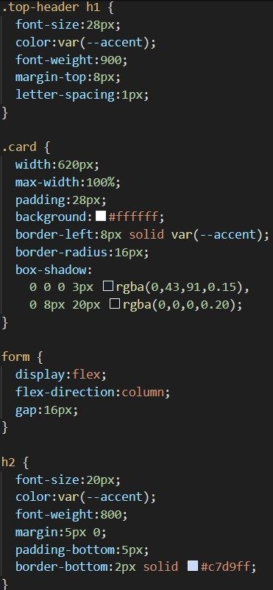
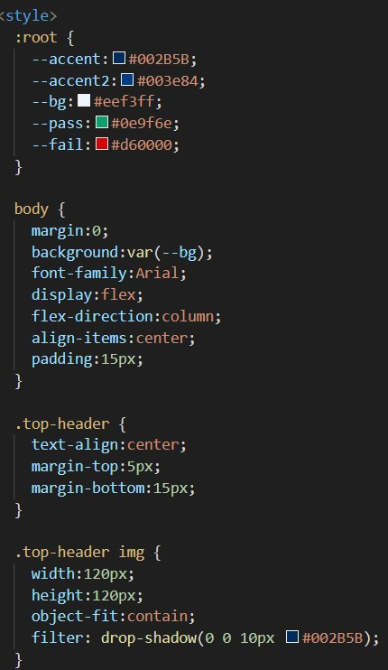

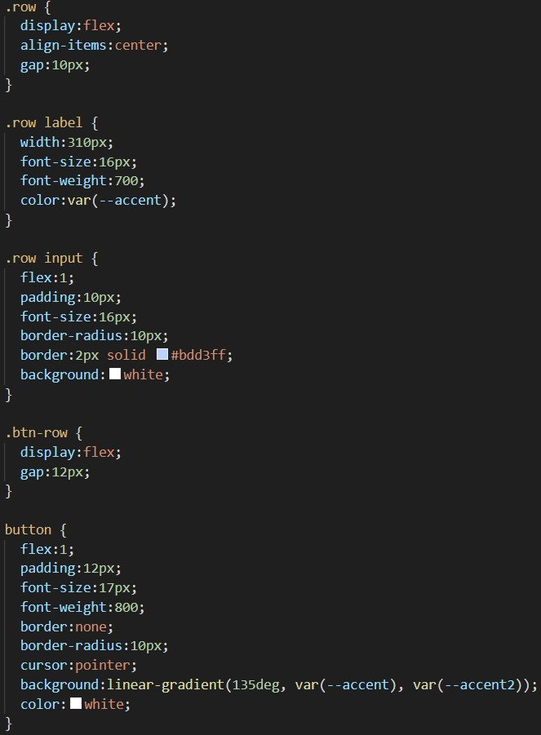
Fig3.1

Fig 3.2
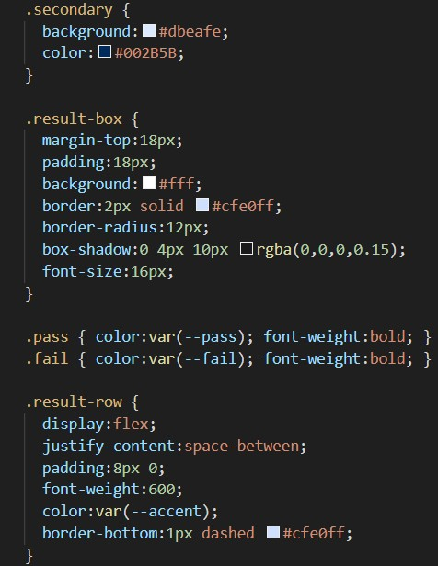

Fig3.4 Fig 3.3

JAVASCRIPT

JavaScript is a powerful, high-level scripting language used to add interactivity, logic, and dynamic behavior to web pages. While HTML provides structure and CSS controls presentation, JavaScript enables a webpage to respond to user actions, validate data, perform calculations, and update content without reloading the page. JavaScript runs directly inside the web browser, making it an essential technology for building modern interactive applications like the Student Grade Calculator.

JavaScript follows an event-driven programming model, meaning certain functions execute when specific actions occur. Events such as clicking a button, entering text, submitting a form, or loading a page can trigger JavaScript code. In the Student Grade Calculator, JavaScript is responsible for handling the "Calculate" button click, collecting the user-entered marks, validating them, and computing results in real time.

Variables and data types form the foundation of JavaScript logic. Using let, const, or var, developers store values such as student marks, totals, and averages. JavaScript supports numeric, string, boolean, array, and object data types. Arrays are particularly useful when storing multiple marks and iterating through them efficiently. JavaScript also provides built-in functions like parseInt() and Number() to convert input values from text fields into numbers for accurate calculations.

Control structures such as if–else, switch, and loops (for, while) help the program make decisions. In the grade calculator, if–else statements check whether a mark is valid, whether a student passed or failed each subject, and which grade category the final average falls into. Loops are used to process multiple subjects, sum their values, and calculate total marks and percentages.

Functions are another key feature of JavaScript. They allow code to be reused, organized, and separated into meaningful blocks. In this project, functions like calculateGrade() manage input validation, mark processing, and displaying results. Event handler functions ensure the calculator works only when all fields are correctly filled.

The Document Object Model (DOM) is how JavaScript interacts with the webpage. Through DOM methods such as getElementById() and innerHTML, JavaScript can read values from input boxes, update result sections, and dynamically modify content.

This makes the webpage responsive and eliminates the need for page refreshes. The DOM ensures smooth user interaction, which is essential for web-based tools.

JavaScript also provides error handling through mechanisms like try–catch, ensuring that unexpected input does not break the application. In the Student Grade Calculator, validation prevents invalid numbers, empty fields, or out-of-range marks from being processed. This improves the reliability and accuracy of the system.

Overall, JavaScript is the core technology that makes the Student Grade Calculator functional, interactive, and user-responsive. By managing user input, performing calculations, validating values, and updating output dynamically, JavaScript transforms a static webpage into an intelligent and efficient tool for evaluating student performance.

XHTML

XHTML (Extensible HyperText Markup Language) is a reformulation of HTML using the syntax rules of XML (Extensible Markup Language). It was created to bring greater consistency, structure, and strictness to traditional HTML.
While HTML is flexible and forgiving with errors, XHTML enforces a stricter coding style to ensure that web pages are clean, well-structured, and compatible across different browsers and devices. The main goal of XHTML is to combine the simplicity of HTML with the rigorous standards of XML, leading to cleaner and more reliable web development.
Unlike HTML, which allows certain mistakes such as missing closing tags or incorrectly nested elements, XHTML requires developers to follow precise rules. Every tag must be properly opened and closed, nested elements must be arranged correctly, and tag names must always be written in lowercase. For example, in XHTML <br /> must be written as a self-closing tag, whereas HTML may simply use <br>. This strictness reduces ambiguity and ensures that documents behave consistently across different environments.

XHTML documents always begin with a specific DOCTYPE declaration and must include the XML namespace. A typical XHTML document structure includes the <html xmlns="http://www.w3.org/1999/xhtml"> attribute, which identifies the document as XHTML. The rules of XML also require that attribute values be enclosed in quotation marks and that all attributes be explicitly defined. This structured format helps software agents, browsers, and validators to interpret the document precisely and without errors.

One of the advantages of XHTML is its improved compatibility with modern web technologies and devices. Because XHTML is based on XML, it enables better integration with other XML-based technologies, such as RSS feeds, SOAP, and various data exchange formats. XHTML also makes web pages more adaptable to non-traditional browsing devices such as mobile phones, screen readers, and embedded systems. The strict syntax ensures that these devices can reliably interpret the document without misrendering.

In projects like the Student Grade Calculator, XHTML principles are often applied even if the document is technically HTML5. Developers follow clean coding practices such as closing all tags, using lowercase element names, and structuring the page logically.
This improves readability, reduces errors, and ensures better compatibility with CSS and JavaScript. For example, form elements, input fields, and layout containers become more predictable and easier for scripts to interact with when written using XHTML-style discipline.

Although HTML5 has largely replaced XHTML as the modern web standard, XHTML still remains relevant in academic learning and professional development because it teaches structured, consistent, and error-free markup coding. It continues to be used in systems that require strict validation and interoperability across platforms.

Overall, XHTML represents an important evolutionary step in web development, bridging the gap between flexible HTML and well-structured XML, while promoting clean, reliable, and standards-compliant web design.

XML

XML (Extensible Markup Language) is a flexible, structured, and standardized language designed to store, transport, and organize data in a human-readable and machine-readable format. Unlike HTML, which focuses on displaying content, XML is used primarily for representing and exchanging data across different systems. It follows strict syntax rules that make data predictable, consistent, and easily processed by computers. XML is widely used in web technologies, configuration files, databases, and communication between applications.

XML is based on a hierarchical structure that uses custom tags defined by the user. Unlike HTML tags that have predefined meanings, XML allows developers to create their own tags to describe data. For example, <student>, <name>, and <marks> can be defined in XML to represent student information. This makes XML highly adaptable for various domains such as finance, education, healthcare, and software systems. Every XML document has a single root element, and all elements must be properly nested and closed, ensuring a clear and logical structure.

An XML document typically starts with a declaration such as <?xml version="1.0" encoding="UTF-8"?>. This declaration is followed by a tree-like arrangement of elements that contain data. All elements must follow case sensitivity, attribute values must be enclosed in quotes, and tags must be strictly opened and closed. These rules ensure that XML files are valid and can be parsed by XML processors, making them reliable for data transmission and storage. XML also supports attributes, which provide additional information about elements, and CDATA sections, which allow special characters to appear without being treated as markup.

XML plays a crucial role in modern web and software development due to its platform independence and compatibility. Many technologies such as SOAP, RSS feeds, SVG graphics, Android app layouts, and configuration files in various software systems are built using XML. Since XML is independent of hardware and software, it enables systems developed in different environments to exchange information smoothly. This makes XML a popular choice for data communication between servers, applications, and web services.

Although XML does not directly affect the visual design of a webpage like HTML and CSS, it influences backend architecture. In projects like the Student Grade Calculator, XML can be used to store student information, subject records, or grading rules in a structured format, especially if the system is expanded into a larger database-driven application. XML ensures that the data remains organized and easy to retrieve, update, or transfer between components.

.

CHAPTER 3

REQUIREMENT SPECIFICATION

HARDWARE REQUIREMENTS

The successful development and execution of the Student Grade Calculator requires a basic yet reliable hardware setup capable of supporting web development tools, browsers, and editing environments. Since this project is based on front-end technologies such as HTML, CSS, and JavaScript, the hardware requirements are minimal compared to large-scale software systems. However, a stable and efficient workstation ensures smooth development, testing, and display of the application.

A personal computer or laptop is the primary hardware component needed. The system should include a modern multi-core processor such as an Intel Core i3 or higher, or an equivalent AMD processor, to ensure efficient multitasking while running a browser, editor, and supporting applications simultaneously. A minimum clock speed of 1.8 GHz is recommended to ensure smooth operation of development environments and browser-based testing.

Adequate RAM (Random Access Memory) is essential for efficient performance. While the project can run on systems with 4 GB RAM, it is recommended to have 8 GB or more for better responsiveness, particularly when running code editors, web browsers, and additional software tools concurrently. Higher RAM reduces lag, improves multitasking ability, and ensures smoother development workflow.

A minimum of 250 GB of storage—HDD or SSD—is required to store project files, software tools, and system resources. However, a Solid State Drive (SSD) is recommended because it provides faster boot times, quicker file access, and improved overall performance. An SSD helps in speeding up development tasks such as opening large software packages, loading browsers, and navigating directories.

A monitor with minimum 1280 × 720 resolution is necessary to view the project layout, preview web pages, and design user interfaces accurately. For improved clarity and workspace, a resolution of 1920 × 1080 (Full HD) or higher is recommended. Standard input devices such as a keyboard and mouse are essential for coding, navigation, and user interface testing.

A stable internet connection is another important hardware requirement, particularly for downloading libraries, accessing tutorials, testing web-based tools, or deploying the application on hosting platforms. Internet connectivity ensures access to documentation and real-time testing across different browsers and environments.

Optional hardware components may include external storage devices for backup, a printer for documentation, and a secondary monitor to improve productivity by allowing code editing on one screen and previewing the application on the other.

Overall, the hardware requirements for the Student Grade Calculator project are minimal but essential for efficient development and testing. A system with a modern processor, sufficient RAM, reliable storage, and stable internet connectivity ensures smooth implementation and provides a comfortable environment for building and demonstrating the application.

SOFTWARE REQUIREMENTS

The Student Grade Calculator is a web-based application developed using front-end technologies such as HTML, CSS, and JavaScript. Since the project runs entirely within a web browser, the software requirements are minimal and easily accessible on any modern computer system. However, having the right set of tools and environments ensures efficient development, testing, and deployment of the application.

The primary software requirement is a modern web browser capable of rendering HTML5, CSS3, and JavaScript. Browsers such as Google Chrome, Mozilla Firefox, Microsoft Edge, or Safari fully support the technologies used in the project. These browsers include built-in developer tools that allow developers to inspect elements, debug JavaScript code, analyze CSS styles, and test responsiveness across different screen sizes.

To create and edit the project files, a code editor or integrated development environment (IDE) is required. Lightweight editors like Visual Studio Code, Sublime Text, Atom, or Notepad++ are widely used due to their simple interface and powerful features. Visual Studio Code is highly recommended because it provides IntelliSense, syntax highlighting, auto-completion, version control integration, and a wide range of extensions for HTML, CSS, and JavaScript development.

The project may also require a local file system or optional local server setup. Since HTML, CSS, and JavaScript run directly in the browser without server-side processing, there is no strict need for a backend server. However, developers may use tools like Live Server (VS Code extension) for real-time reloading and easier testing. This enables the browser to automatically update the webpage whenever changes are made to the code.

For documentation and reporting, Microsoft Word, Google Docs, or any word-processing software is necessary to prepare the project report, screenshots, and explanations. Additionally, web-based validation tools such as W3C HTML Validator and W3C CSS Validator can be used to verify the correctness of the code and ensure compliance with international web standards.

CHAPTER 4
DESIGN
4.1 DESIGN GOALS

The design goals of the Student Grade Calculator focus on creating a system that is efficient, user-friendly, visually appealing, and functionally accurate. These goals guide the development process to ensure that the final product not only performs calculations correctly but also provides a smooth and enjoyable user experience. Good design plays a crucial role in usability, especially in academic tools where clarity and simplicity are essential.

One of the primary design goals is simplicity and ease of use. The interface is developed to be intuitive so that users can easily enter student details and marks without confusion. By organizing input fields in a clean and structured manner, the system ensures that users can navigate the form quickly. Clear labels, properly grouped sections, and logical flow help reduce the chances of input errors.

Another important design goal is accuracy and reliability. The system must produce correct calculations every time, regardless of the input order or values. This includes accurate computation of total marks, average, percentage, and grade. Reliable input validation is also part of this goal—ensuring that users cannot enter invalid data such as negative numbers, text in numeric fields, or marks exceeding the maximum limit. The design guarantees that users receive immediate corrective feedback in case of invalid inputs.

Visual clarity and aesthetic appeal is also a significant design objective. A clean layout, proper use of spacing, readable fonts, and consistent color themes enhance the overall appearance of the application. These elements make the interface pleasant and reduce cognitive load, especially for students and teachers who may use the application frequently. The use of subtle shadows, rounded corners, and color highlights improves readability and organization.

A major design goal is responsiveness and accessibility. The system should be accessible across different devices—laptops, desktops, and tablets—with consistent performance. Responsive design ensures that elements adjust smoothly to varying screen sizes. Accessibility considerations such as sufficient text contrast, keyboard navigability, and proper labeling help users with different abilities interact with the application easily.
Another key goal is modularity and maintainability. The application is structured so that components such as HTML layout, CSS styling, and JavaScript logic are separated. This modular approach makes it easier to update the system in the future, add more subjects, improve the user interface, or integrate new features like data storage or result export. Clean and well-organized code improves maintainability for developers who may enhance or extend the project later.

Finally, the design aims for real-time feedback and interactivity. Users should see results instantly upon clicking the calculate button, without page reloads. This enhances efficiency and reflects modern web application standards. Clear, concise output formatting—including subject-wise pass/fail status—ensures that users understand the results immediately.

Overall, these design goals ensure that the Student Grade Calculator is not only functional but also efficient, visually appealing, accurate, and easy to maintain. By prioritizing usability, responsiveness, and clarity, the system fulfills the expectations of an effective educational to

CHAPTER 5

IMPLEMENTATION

The implementation phase of the Student Grade Calculator involves translating the planned design, logic, and structure into a functional web application using HTML, CSS, and JavaScript. This phase converts theoretical concepts into a practical, interactive interface that performs grade calculations accurately and displays results clearly. Implementation focuses on building the user interface, developing the core calculation logic, validating user input, and integrating all components to work together seamlessly.

The implementation begins with the creation of the HTML structure, which forms the backbone of the application. All input fields, labels, buttons, and output containers are defined using semantic and well-organized HTML tags. Separate sections are created for student information, subject marks, and results. The form element is designed to collect user input without refreshing the page, and placeholders guide users on the type of data to enter. Proper use of IDs and labels ensures easy access to elements through JavaScript for validation and processing.

Next, the CSS layer is implemented to enhance the visual layout and improve usability. Styling includes defining color schemes, adjusting spacing, customizing input fields, and designing buttons with hover effects. The interface is made clean, modern, and responsive by using layout techniques such as Flexbox. Shadows, borders, and font styling are applied to increase readability and create a professional appearance. CSS ensures that the application looks well-organized and provides a smooth user experience across different screen sizes.

The core functionality of the system is implemented using JavaScript, which performs all the calculations and dynamic interactions. JavaScript retrieves values from input fields, checks for valid input, and prevents calculation unless all required fields are completed. Validation logic ensures that only numeric values between 0 and 100 are accepted. If any subject score is below the passing mark, the system identifies the failure and immediately displays a subject-wise pass/fail breakdown.
If the student passes in all subjects, JavaScript proceeds to compute the total marks, average, percentage, and the final grade based on predefined grading criteria. The results are dynamically displayed within a formatted output container without reloading the page. DOM manipulation functions such as getElementById(), innerHTML, and event handlers ensure smooth interaction between the user
Additional functionality such as the Reset button is implemented to clear the form and hide previous results, allowing users to perform new calculations easily. Input clamping functions prevent out-of-range values, and strings are automatically formatted for consistency in fields such as USN.

Throughout the implementation, the code is organized into logical sections to maintain readability and allow future modifications. Debugging tools in the browser are used to test each component and ensure error-free operation. The final system integrates structure, style, and logic to deliver a reliable and user-friendly grade calculator.

Overall, the implementation successfully transforms the planned design into a functioning application, ensuring accurate grade computation, responsive interaction, and a visually appealing user interface
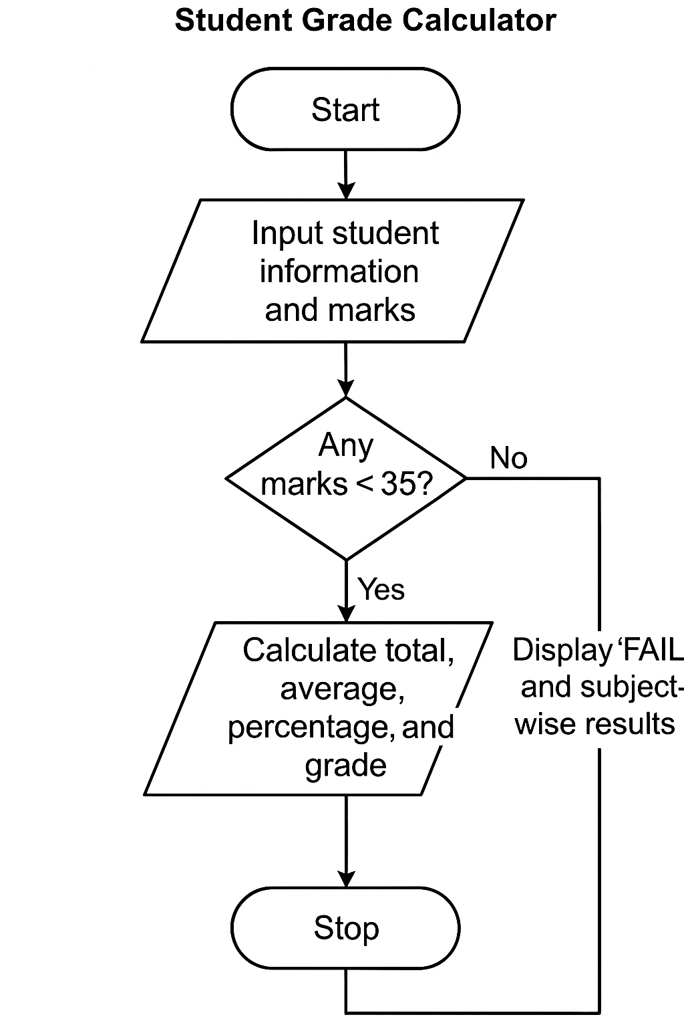

Fig 5.1

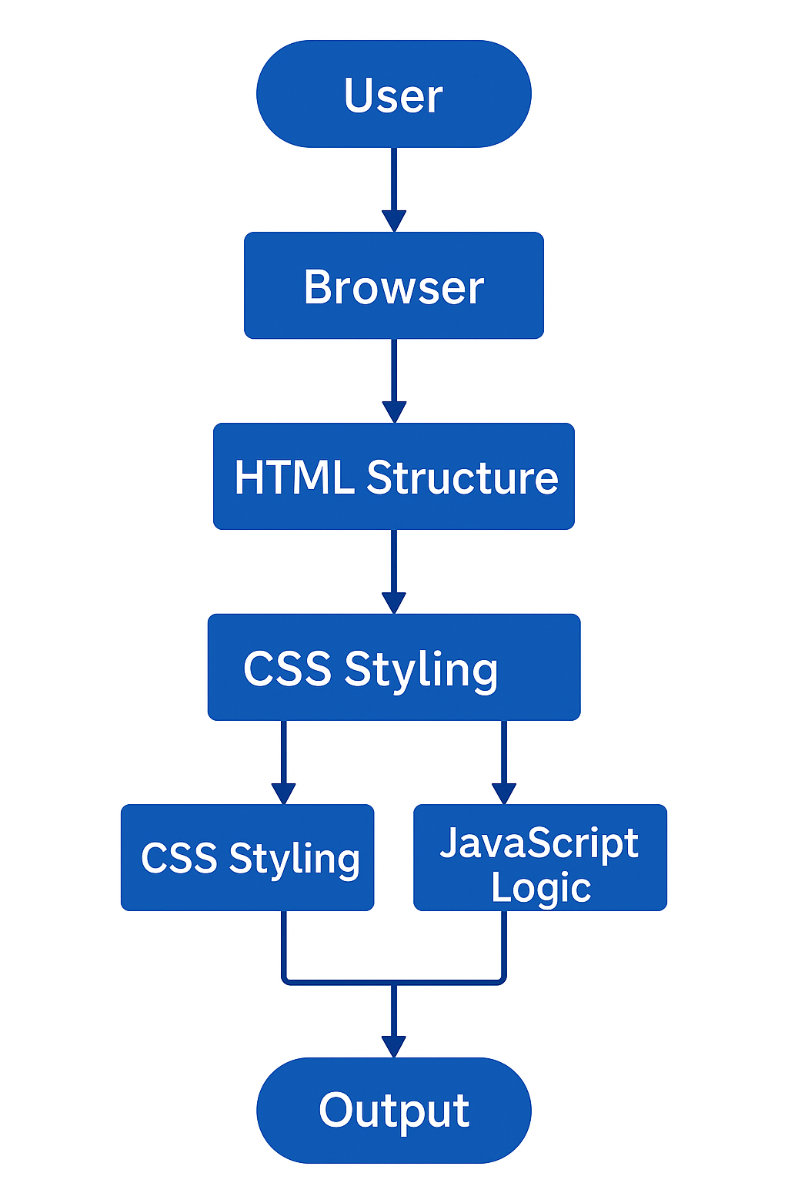

Fig 5.2

CHAPTER 6
RESULTS

The results of the Student Grade Calculator demonstrate the successful implementation of a functional, accurate, and user-friendly web-based application for evaluating student performance. The system is capable of collecting user inputs, validating the data, calculating grades, and presenting the results in a clear and organized format. The outcomes of the project highlight the effectiveness of the design and implementation strategies used throughout the development process.

One of the key results is the smooth and intuitive user interface that enables users to enter student details and subject marks without confusion. The form layout is neatly structured, and all fields are clearly labeled, ensuring that users understand what information needs to be provided. The interface is responsive and visually appealing, making the tool suitable for frequent use by students and academic staff.

The system successfully performs automatic input validation, one of the major objectives of the project. When users attempt to submit incomplete or invalid data, the application prevents the calculation and displays a helpful alert message. This ensures that the inputs remain accurate and reduces the chances of errors in the final computation. The validation logic effectively handles issues such as blank fields, alphabetic characters in numeric fields, and marks outside the range of 0–100.

The primary functionality of the application—accurate grade calculation—is achieved with reliability. The system correctly computes the total marks, average score, and percentage based on the marks provided. It also applies the grading criteria accurately to classify the student’s performance into categories such as A+, A, B, C, D, or Fail. This ensures consistency with academic grading standards.
Another significant result is the correct detection of subject-wise pass/fail status. Even if the student scores well overall but fails in a single subject, the system identifies the failure and displays a detailed breakdown showing which subjects were passed or failed. This provides transparency and helps users understand the reasons behind the final result.

The output section of the application is clearly formatted and easy to read. It includes essential information such as the student’s name, USN, total marks, average score, percentage, and final grade. The subject-wise breakdown helps users to analyze performance in each course. By using dynamic DOM manipulation, the results appear instantly without reloading the page, enhancing the user experience.

Testing across different browsers and screen sizes also shows that the application performs consistently. Features such as input clamping, reset functionality, and responsive design work smoothly in all tested environments. The system is stable, visually consistent, and free from major bugs, confirming that it meets the requirements defined at the start of the project.

Overall, the results demonstrate that the Student Grade Calculator successfully fulfills its objectives by providing a reliable, efficient, and easy-to-use tool for academic grade computation. The project outcome validates the design choices, implementation strategies, and technologies used, confirming the effectiveness of the developed system.

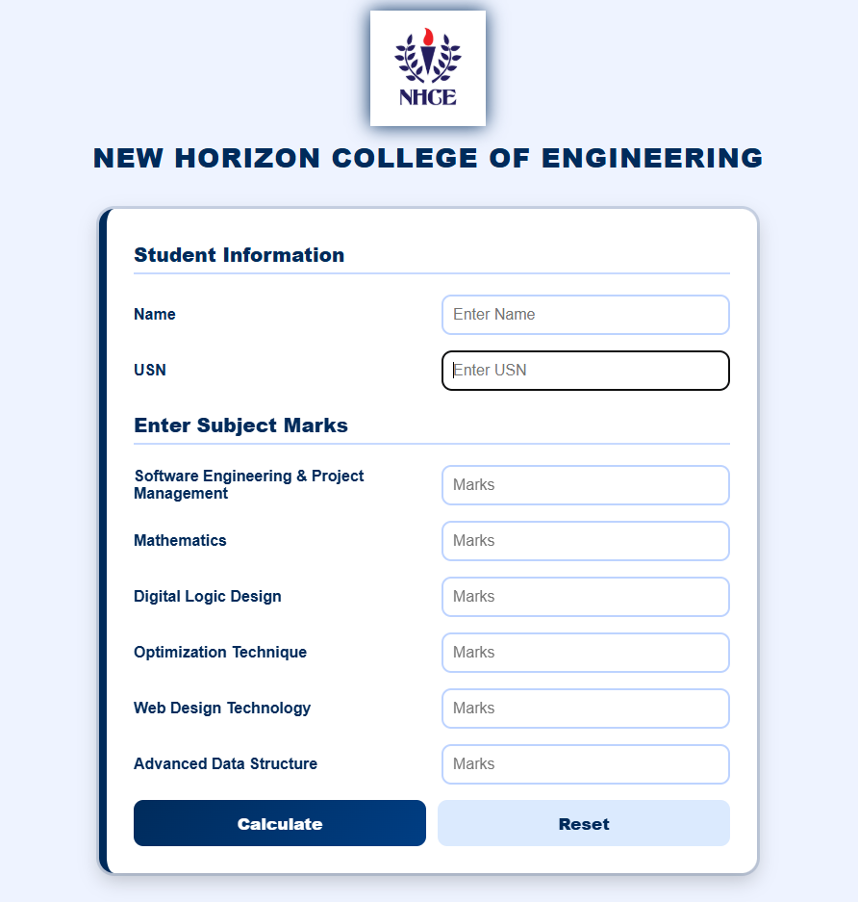

Fig 6.1

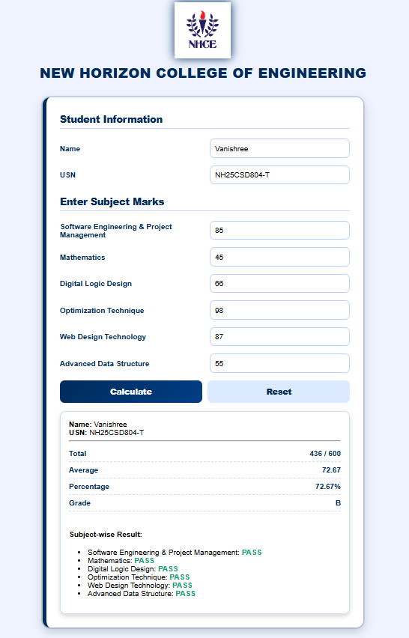

Fig 6.2

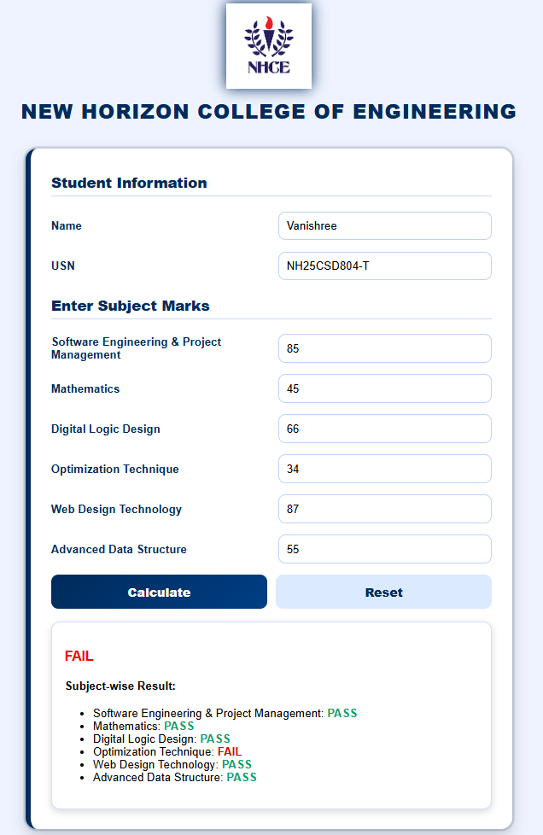

Fig 6.3

CHAPTER 7
CONCLUSION

The Student Grade Calculator project successfully fulfills its objective of providing a simple, efficient, and accurate tool for evaluating student performance. Through the combined use of HTML, CSS, and JavaScript, the system delivers a user-friendly interface that enables users to input marks, validate entries, compute results, and display outcomes in a structured and meaningful format. The project demonstrates how web technologies can be effectively utilized to create a practical solution to a common academic requirement.

The system ensures accuracy in calculations by automatically computing total marks, averages, percentages, and final grades based on predefined criteria. The inclusion of input validation prevents errors by restricting invalid entries such as text characters, negative values, or marks exceeding the allowable range. This results in more reliable output and reduces the likelihood of human error during manual grade computation.

One of the major achievements of the project is the development of an intuitive and visually appealing interface. The layout is designed to be clean and easy to navigate, ensuring that users—whether students or teachers—can quickly understand and operate the system. The use of dynamic styling and responsive design enhances the overall user experience and makes the application accessible across different devices and screen sizes.

The project also showcases the power of JavaScript-driven interactivity. Without requiring page reloads, the system instantaneously processes data and displays results, demonstrating efficient use of the Document Object Model (DOM). The detailed pass/fail breakdown further adds clarity, allowing users to identify strengths and weaknesses in subject-wise performance.

From a technical perspective, the project encourages structured development methodology, modular coding, and good design practices. It highlights the importance of clear separation between structure (HTML), presentation (CSS), and logic (JavaScript), making the system easy to understand, maintain, and expand. The application can be extended in the future to include additional features such as database integration, result storage, downloadable reports, or integration with school management

REFERENCES

W3Schools, HTML Tutorial.

W3Schools, CSS Tutorial.

W3Schools, JavaScript Tutorial.

Mozilla Developer Network (MDN), HTML Elements Reference.

Mozilla Developer Network (MDN), CSS Reference.

Mozilla Developer Network (MDN), JavaScript Guide.

GeeksforGeeks, JavaScript DOM Concepts and Examples.

TutorialsPoint, Basics of HTML, CSS, and JavaScript.

New Horizon College of Engineering, Academic Guidelines and Formatting Standards.

Stack Overflow Community, JavaScript Validation and Form Handling Discussions.

GitHub Documentation, Client-Side Web Development Practices.

Sharma, P. (2020). Web Technologies and Applications. TechPress Publications.

Patel, R. (2019). Introduction to Web Design. DreamTech Press.

